
CC-215-L: Database Systems Lab

Faculty of Computing & Information Technology

BS(IT/CS) Morning - Fall 2023
LAB – 01

The objective of this lab is to:
- Introduction to SQL basics
- Select, Where clauses
- In, Alias, Between
- Operators (Logical + Arithmetic)
Course & Lab Instructor: Dr. Asif Sohail
- IMPORTANT INSTRUCTION
    - WRITE THE QUERY ON YOUR WORD DOCUMENT AS WELL AS ALSO PASTE THE SCREENSHOT OF THE SCREEN ON THE WORD DOCUMENT
    - For Example:
      - Question: Write a Query to Display all Employees Records
      - Answer: SELECT * FROM EMP
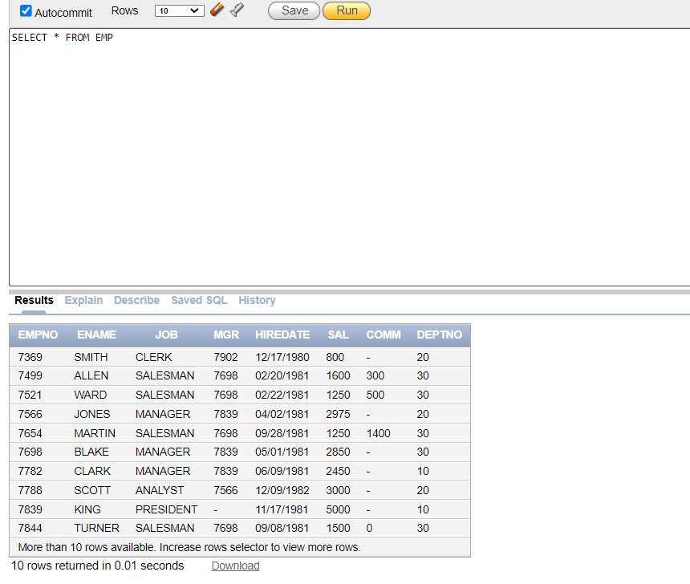
LAB TIMING : 90 MINS
TOTAL MARKS : 40
Task 01: [5 marks]
- Oracle Configuration (3 Marks)
- Scripts Uploading (2 marks)
Task 02: [15 marks]
- Write an SQL query to display the names of all departments.
select dname from dept
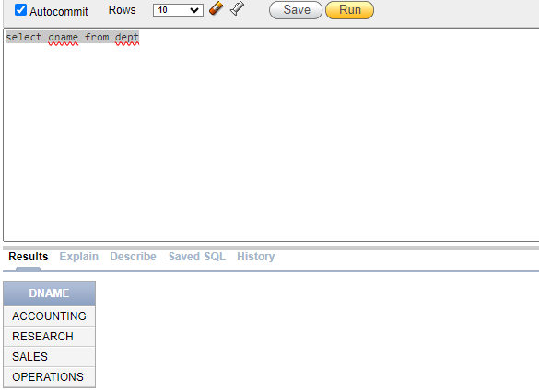
- Write an SQL query that display the employees working in department 20.
select * from EMP where DEPTNO = 20
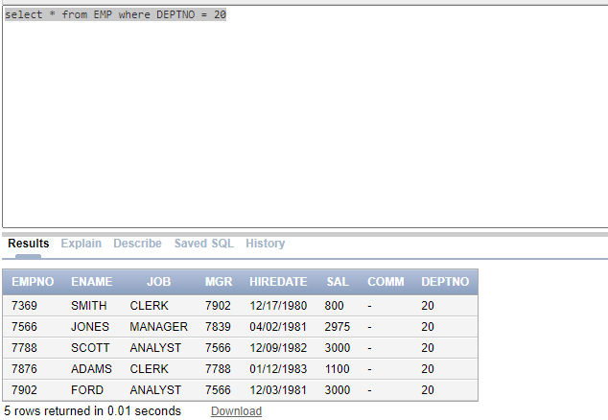
- Write an SQL query to display the Location of Department no 40.
select LOC FROM DEPT WHERE DEPTNO = 40
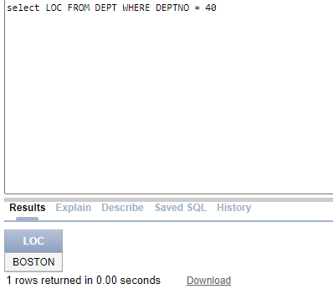
- Write an SQL query to display job and salary details of the employee “KING”.
select JOB , SAL from EMP where ENAME = 'KING'
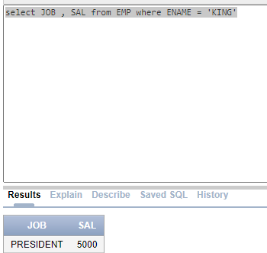
- Write an SQL query to display the name and salary of the employee who works as a ‘Clerk’ or ‘Salesman’.
select ENAME , SAL from EMP where JOB = 'CLERK' OR JOB = 'SALESMAN'
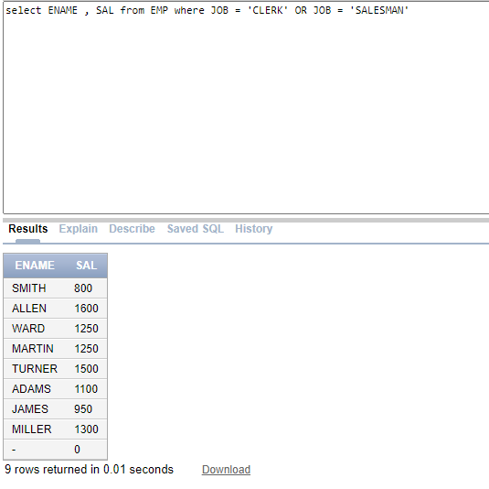
- Write an SQL query that displays ENAME,JOB,SAL and calculates the Annual Salary of employees. The column containing annual salary must be named as “Employees Annual Salary”.
select ENAME , JOB , SAL, SAL * 12 as "Employees Annual Salary" from EMP
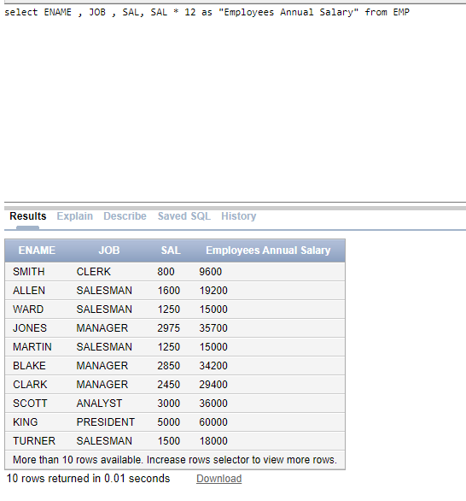
- Write an SQL query that display the employee’s data working in either department 20 or 30. (Use of OR operator is not allowed)
select * from EMP where DEPTNO in (20,30)
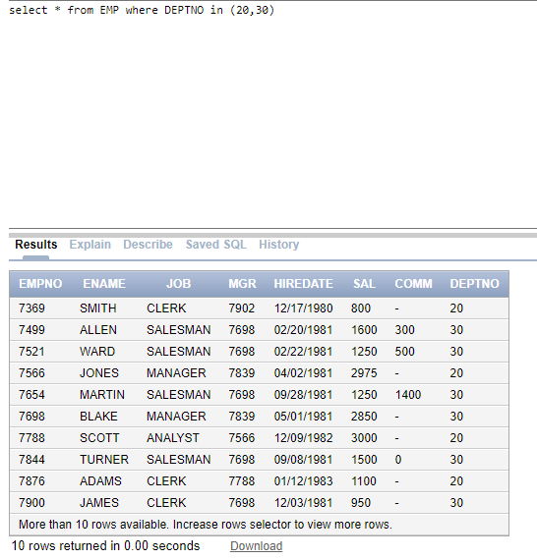
- Write an SQL query to display the EMPNO,ENAME,JOB,SAL of those employees whose salaries lies in the range of (1000-2500).
select EMPNO , ENAME, JOB, SAL from EMP where SAL between 1000 and 2500
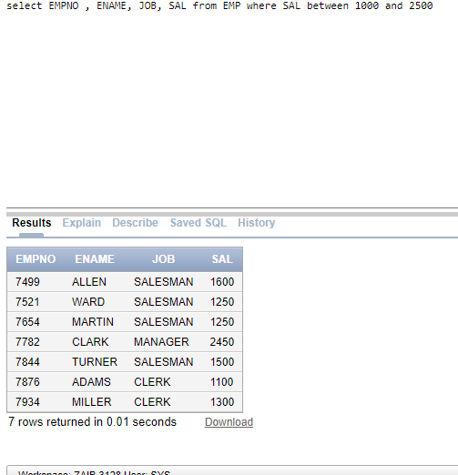
- Write an SQL query that outputs the following.
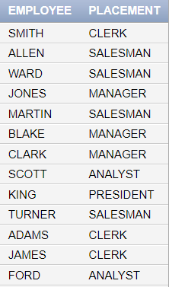
select ENAME as "EMPLOYEE", JOB as "PLACEMENT" from EMP

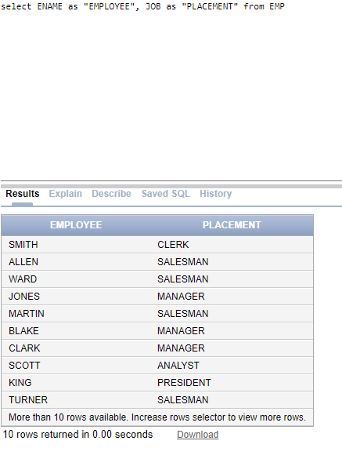
- Write an SQL query to display all the Salesmen earning more than 1200.
select ENAME from EMP where JOB = 'SALESMAN' and SAL > 1200
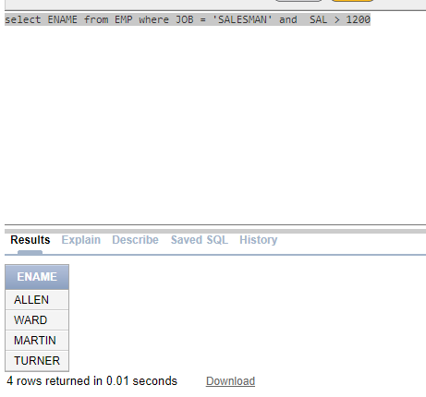
- Write an SQL query to display records of employees who either belong to the Managing Department number 30 or are Analysts.
select * from EMP where DEPTNO = 30 or JOB = 'ANALYST'
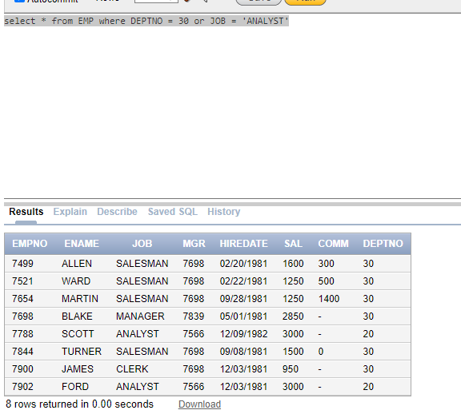
- Write an SQL query which displays the employees working under manager (7698).
select ENAME from EMP where MGR = 7698
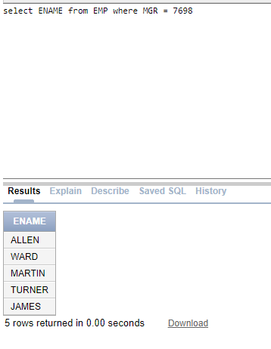
- Write an SQL query the displays a column named “MONTHLY SAL” as “BONUS SALARY” for all the CLERKS. NOTE: “BONUS SALARY IS 10% of monthly salary”. Display the name of the employees alongside.
select ENAME , SAL as "MONTHLY SALARY", SAL*0.1 as "Bonus Salary" from EMP where JOB = 'CLERK'
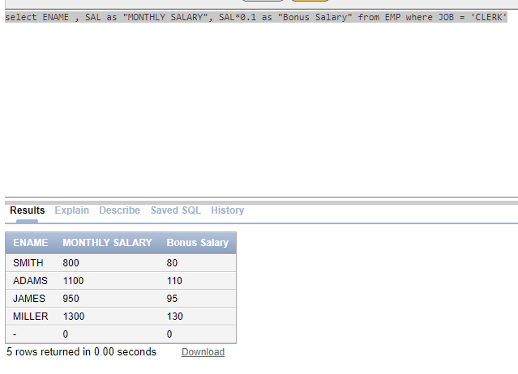
- Write an SQL query to display employees hired after “02/20/1981”.
select ENAME from EMP where HIREDATE > '02/20/1981'
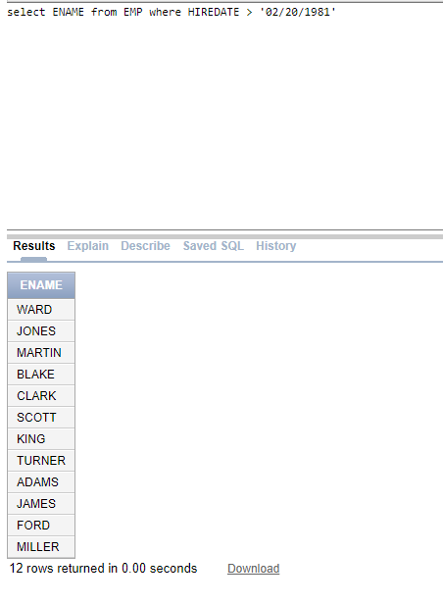
- Display the quote “O Captain! My Captain!” multiple times as shown below.
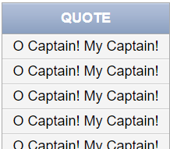
select '"O CAPTAIN! MY CAPTAIN"' as "QUOTE" from EMP
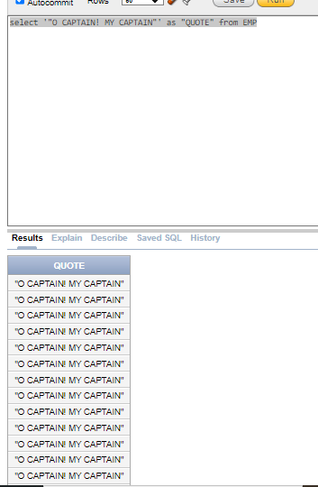

Task 02: [10 marks]
- Write an SQL query to display ENAME, JOB , SAL , YEARLY SALARY of the employee who earns more than 15000 per annum and also earns monthly commission.
select ENAME, JOB , SAL , SAL * 12 as "YEARLY SALARY" from EMP where SAL * 12 > 15000 and COMM <> 0
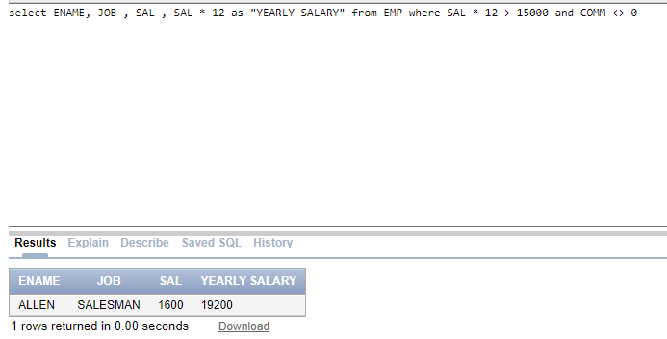
- List all employees who either have a commission or their salary is between 1500 and 2500 but are not in department 30.
select ENAME from EMP where COMM <> 0 or SAL between 1500 and 2500 and DEPTNO <> 30
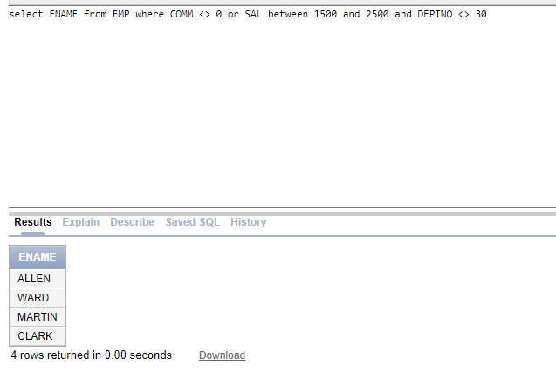
- Retrieve the employees whose salary, when increased 50%, is greater than 2000, and their commission is less than 500. Also show increased salary with proper alias.
select ENAME, SAL ,(SAL + (SAL * 0.5)) as "Increased Salary" from EMP where (SAL + (SAL * 0.5)) > 2000 and COMM < 500
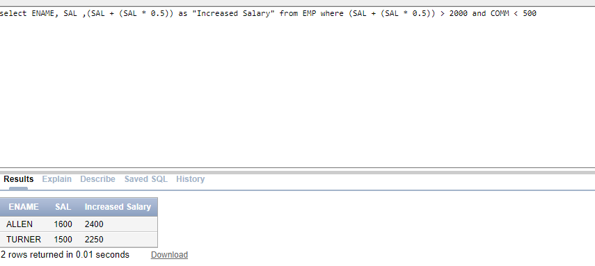
- The company has decided to impose 15% of Indirect taxes on the quarterly Salary on the Salesman working in department 30. The tax is applied after each quarter.
Write an SQL query to display the “Quarterly Taxed Income” and “Total Tax Collected” after the completion of year along with EMPNO, ENAME, JOB.
SELECT EMPNO, ENAME, JOB, (SAL / 4) * 0.85 AS "Quarterly_Taxed_Income", SAL * 0.15 AS "Total_Tax_Collected" FROM EMP WHERE JOB = 'SALESMAN' AND DEPTNO = 30;
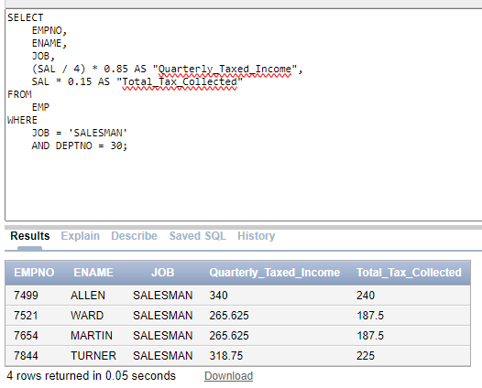
- The company has implemented a new compensation strategy for its clerical staff. Employees in this category will receive a bonus equivalent to 25% of their annual salary. Additionally, the company is providing a yearly education allowance for their children, calculated as 10% of the resultant salaries after the bonus is applied, which will then be deducted from the total. Write an SQL Query to display the “Annual Salary” of employees, “Bonus”, “Increased Salary”, “Education Allowance” and “Final Salary”.

Task 03: [6 marks]
- The company gives employees three different allowances based on their salary:
Medical Allowance: 10% of the employee's salary
House Rent Allowance (HRA): 15% of the employee's salary
Transport Allowance: 5% of the employee's salary
Write an SQL query to calculate each allowance separately and also calculate the total allowance for each employee. Display the employee's name, salary, each individual allowance, and the total allowance. Use proper aliasing for each column.

select ENAME ,SAL ,SAL* 0.1 as "MEDICAL ALLOWENCE" ,SAL*0.15 as "HOUSE RENT", SAL * 0.05 as "TRANSPOSE ALLOWENCE",(SAL* 0.1)+(SAL*0.15)+(SAL * 0.05) as "TOTAL ALLOWENCE"
from EMP
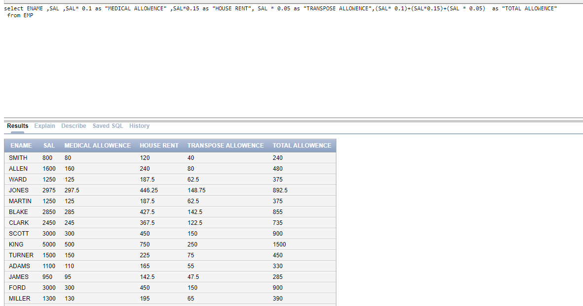
- Display all the employees whose name starts with the letter B. (Use of “Like” keyword is not allowed).

SELECT EMPNO, ENAME, JOB FROM EMP WHERE SUBSTR(ENAME, 1, 1) = 'B'
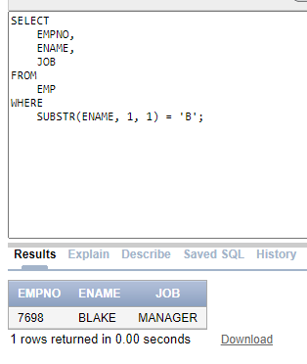
With use of like…:-
SELECT EMPNO, ENAME, JOB FROM EMP WHERE ENAME LIKE 'B%';

Task 04: [4 marks]
VIVA VOCE

